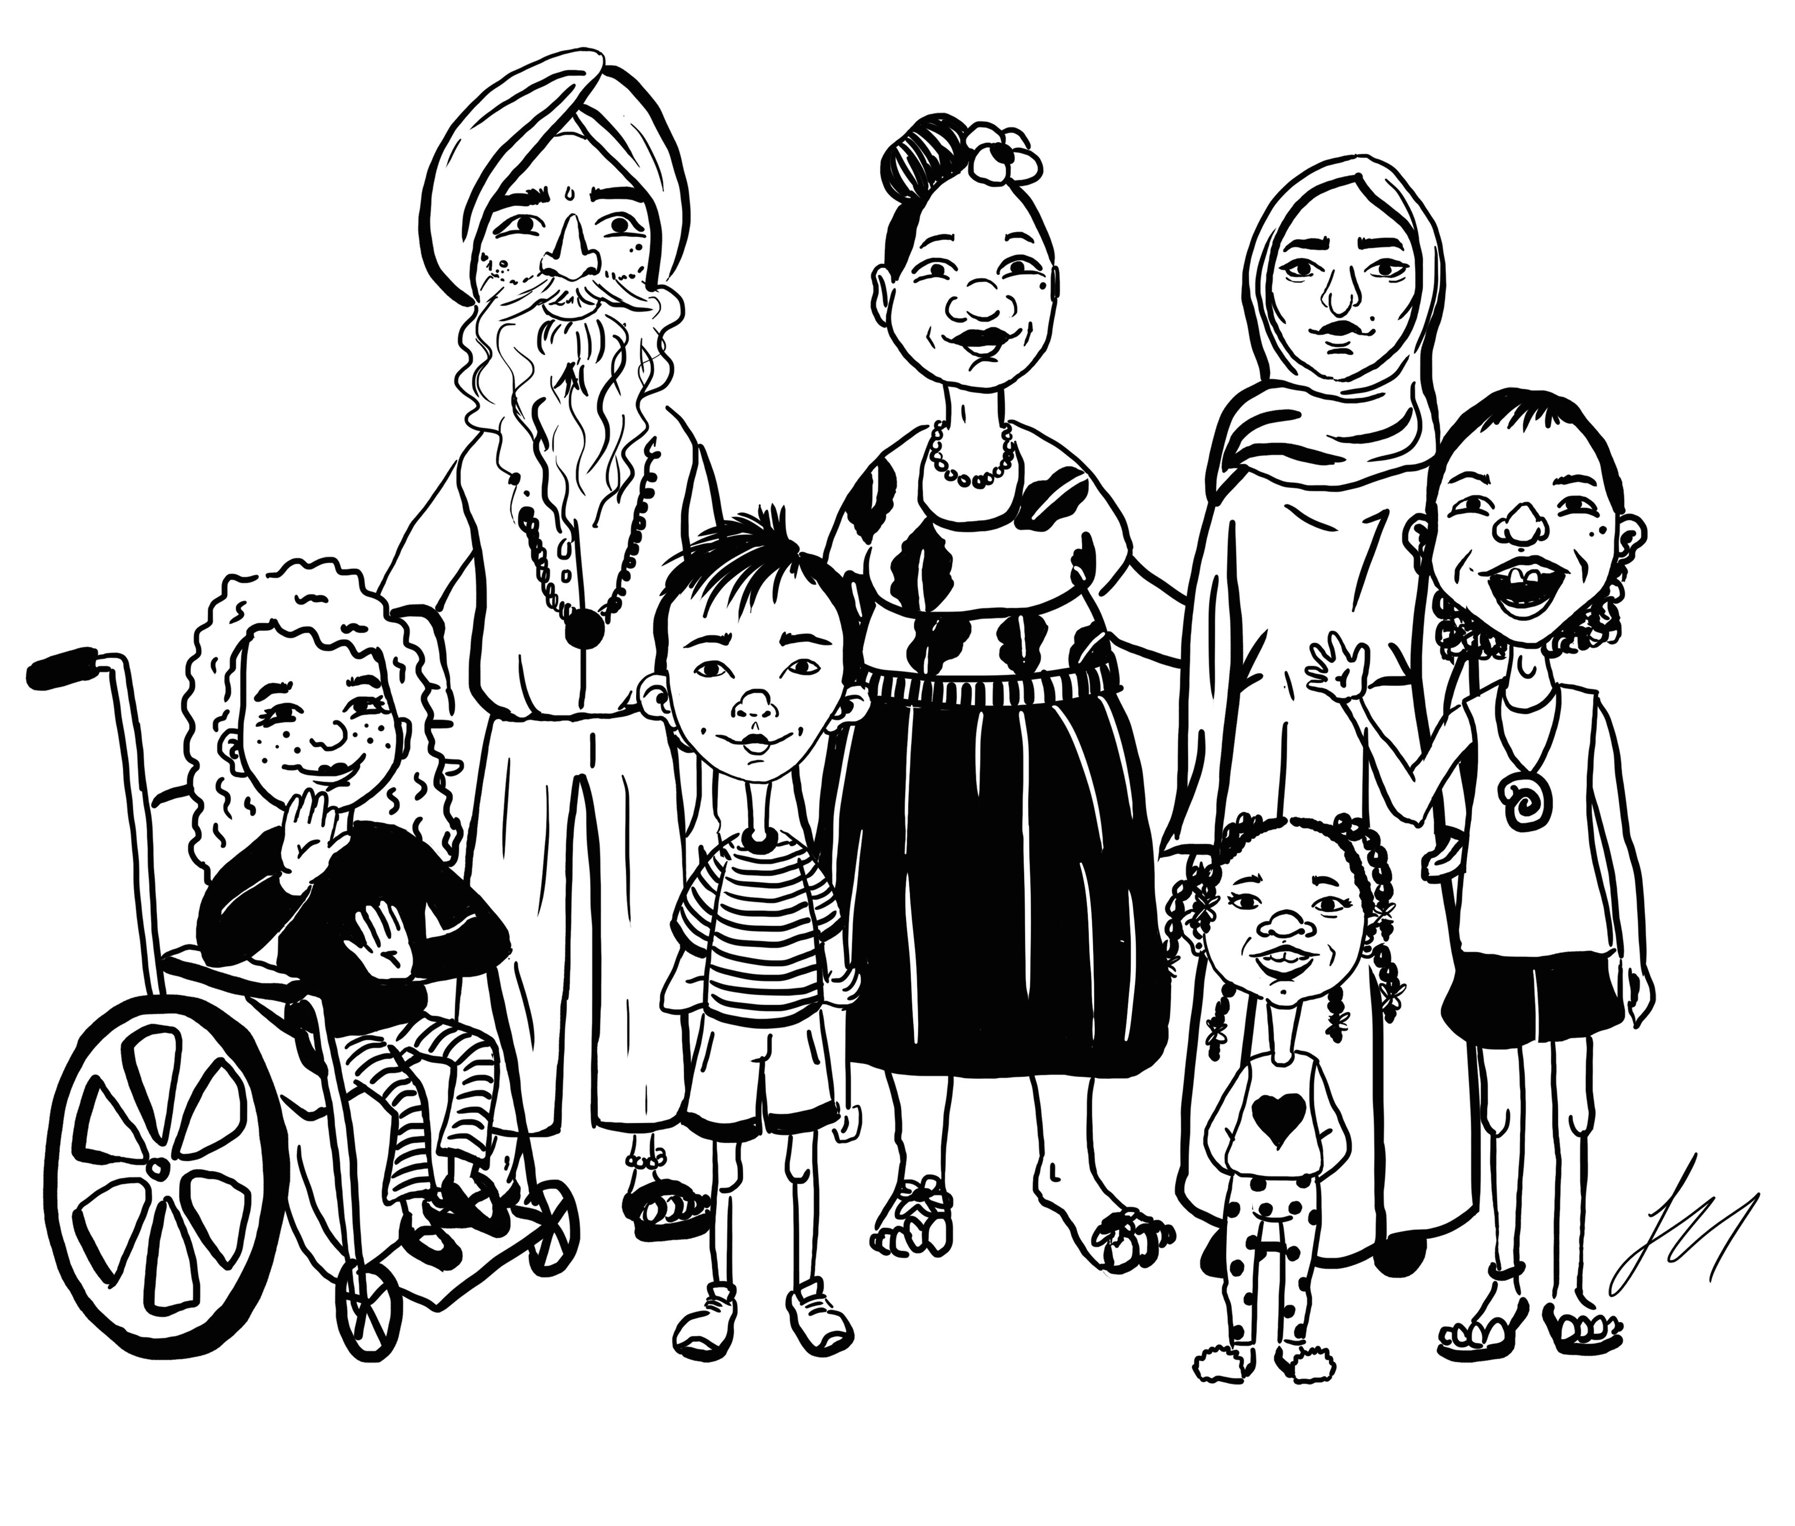
•
•
•
•
www.facebook.com/CommunityLanguagesAssociationNZ/
Community Languages Association of New Zealand (CLANZ)

English text by Hilary Smith, illustration by Sarah Illingworth. © 2017 CLANZ Translated by:

